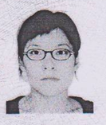
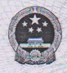
Peoples’ Republic of China
Resident Identification Card

Authority Taiyuan Public Security Bureau
Date of expiry 26 June 2006 –26 June 2026

Name: ###
Sex: Female
Date of Birth: 18 Sep., 1972
Nationality: Chinese
Address: Room 502, Building 1,
Oil Company Family Buildings,
Jixiang Subdistrict, Dadongliu Village,
Jiancaoping District, Taiyuan City, Shanxi
ID Number: #####

